**Proposed Topic: Scope of microbiological tools for salinity stress mitigation in plants considering different climatic regions**

**Group Members:**

**Amra Tariq**

**Mahrukh Rafique**

**Ayesha Abid**

**Iqra Younas**

**Abstract:**

Salinity is a foremost challenge worldwide affecting the crop production. The unfavorable (or high) salt concentrations cause hyperosmotic conditions and ionic imbalance resulting in the oxidative stress conditions for plants. Salt salinization can be caused naturally or anthropogenically by inadequate irrigation and fertilization.  Furthermore, salinity influences plant growth regulators and inhibits seed germination, root growth, and shoot growth. Microorganisms could play a significant role in this respect, if we exploit their unique properties such as tolerance to saline conditions, genetic diversity, synthesis of compatible solutes, production of plant growth promoting hormones, bio-control potential, and their interaction with crop plants. Beneficial effects of using microorganisms in saline soil conditions, potentially contribute to expanding crop production to otherwise unproductive soils. This method is cost efficient as compared to typical strategies used to cope with salinity. Plants having halotolerant PGPB in their root surroundings improve in diverse morphological, physiological, and biochemical aspects due to their multiple plant-growth-promoting traits. These beneficial effects are related to the excretion of bacterial phytohormones and modulation of their expression, and the release of organic compounds that modify plant rhizosphere and function as signaling molecules, thus contributing to the plant’s salinity tolerance. Previous literature has coined multiple approaches to mitigate the salinity stress in plants, and among all the microbe-assisted technologies were appraised for their practicability and economic benefits But the scope of microbiological tools in with respect to different climatic regions: arid, semi-arid, hyper-arid, and dry subhumid is still unanswered. This review will thrash out the influence of plant growth promoting microorganisms (PGPMs) on soil pH, nutrient availability, moisture, and mobilization to specify the applicability of PGPMs based on climatic(or regional) differences.

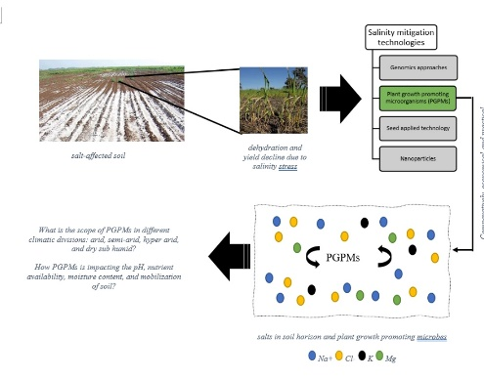

**Tentative Outline**

Authors: Amra Tariq, Ayesha Abid, Mahrukh Rafique, Iqra Younis

Scope of Microbiological Tools for Salinity Stress Mitigation in Plants Considering Different Climatic Regions

**Introduction**

*problem statement

*facts and data through reports

*soil salinity an emerging issue

*impacts of salinity stress on plants will be discussed

**Amelioration of Salinity Stress:** Recently Developed Strategies

*precise review of already (all) existing methods

**Plant Growth Promoting Microorganisms: Salinity Stress Alleviation Tool**

**Mechanisms used by PGPMs against salinity**

**Bacterial Strains for Salinity Stress Mitigation**

*tabular representation of bacterial strains that have discovered as effective PGPM for mitigating soil salinity stress

**Fungal Strains for Salinity Stress Mitigation**

*tabular representation of fungal strains that have discovered as effective PGPM for mitigating soil salinity stress

**Scope of PGPMs with respect to Climatic Variations**

**Arid Region**

*impact of abiotic factors on the success of PGPMs

**Semi-arid Region**

*impact of abiotic factors on the success of PGPMs

**Hyper Arid**

*impact of abiotic factors on the success of PGPMs

**Dry Sub-humid**

*impact of abiotic factors on the success of PGPMs

**Conclusion and Future Perspective**

*summary

*implications of food security

*future direction of microbiological tool in salinity stress mitigation